Cairo University

Faculty of Computers and Artificial intelligence Department of Computer Sciences

Project Title

Supervised by

Dr. Lamia Abo Zaid

Implemented by

|  |  |
| --- | --- |
| 20216055 | Doha Sherif |
| 20216140 | Mariam Ashraf |
| 20216141 | Mariam Emad |
| 20216142 | Antonios Elia |
| 20215059 | Youssef Osama |

Graduation Project

Academic Year 2024-2025

Midyear Short Documentation

Project Short Documentation

**General Guidelines:**

* The cover page should be as the previous page.
* The overall document should not exceed 15 pages.
* Font in the overall document should be consistent in family and size.
* Diagrams and images should be captured with high resolution.
* Sections and subsections should have meaningful titles and should be correctly numbered.

**The document should include the following content:**

1. **Abstract**

It contains around 100 to 200 words that describe the existing problem, your motivation to solve it, and the tools you are using to implement that solution. In case you are working on a research problem, you should clearly state the research question you are going to answer.

1. **Background (introduction to the main area of the projects, motivation, beneficiary, main techniques, main application)**

**the main area of the project:**

The main idea of our project is to create an all in one platform for event planning. It is a website where users can book venues, choose services (like caterers, DJs, or photographers), manage their event details, and even send invitations. Everything happens in one place, without the need to switch between apps, make phone calls, or deal with multiple separate payments. Our main goal is to simplify the whole experience for anyone planning an event while also helping service providers and venue owners grow their businesses online.

**Motivation:**

Our main motivation was driven by how stressful and time consuming event planning can be especially when people don’t have an all in one system. People usually need to check different platforms, talk to vendors individually, and manually track everything. On the other side a lot of smallvendors and venues don’t get the visibility they deserve or they don’t have easy tools to manage and track their bookings.  
So we decided to build a solution that brings both sides together on one smooth, modern platform making things easier, faster, and more organized.

**Beneficiary:**

* Customers who want to easily plan and organize personal events
* Vendors who want more visibility, organized booking tools, and a space to show off their services and packages

**Main Techniques**

**Main Application**

1. **Problem definition**

Event planning is a huge process that often cause stress and inefficiency. Customers tend to visit multiple websites or contact different vendors individually to find the right venue, book services, and organize event details. This scattered process leads to confusion, delays, and sometimes missed bookings. On the other hand many vendors and venue owners struggle to attract enough customers because they lack a unified platform to show their services. They also have difficulty managing their availability, bookings, and payments in an organized way. In fact most places organize these things manually. Moreover, existing solutions often focus only on parts of the event planning process such as venue booking or service reservations but none provide a complete, integrated system that covers everything from searching and booking to event management and communication. Our project addresses these gaps by offering a single platform that connects customers, vendors, and admins, enabling smooth coordination, reliable bookings, and effective event management all in one place.

1. **Related work:**
2. **The existing similar implementations to the idea of your project, if any.**
3. **Venu.ai**

**Strengths:**

* Choose the type of venue based on your event (wedding, birthday, meeting, etc.)
* View venue prices
* View different pricing packages
* See the maximum capacity of each venue
* Browse photos of the venues
* Select optional add-ons
* Filter venues by location
* Chat directly with the venue host
* Book a site visit to the venue

**Weaknesses:**

* Cannot view available booking dates in real-time
* No customer feedback or reviews
* Only supports venue booking, no event management features

**Key Features:**

* Venue booking
* Host chat
* Location based search
* Payment processing
* Site visit booking

1. **Eventplanner.net**

**Strengths:**

* Manage all major event services from the app
* Filtered search by price, number of people and location
* Assign tasks and sets deadlines for event planning

**Weaknesses:**

* Cannot complete bookings directly in the app (redirects users to the venue’s website)
* User experience is challenging due to difficult navigation and poor design

**Key Features:**

* Venue booking
* Event services booking
* Task management and checklists

1. **Tlt concepts**

**Strengths:**

* Shows previous events held at the venue to give users a real idea of how the place looks

**Weaknesses:**

* No online booking, booking requires contacting the host directly
* Limited number of venue options available

**Key Features:**

* Direct contact with the host
* Display of past events to show the venue

1. **Plein Air (Egypt)**

**Strengths:**

* Offers complete event packages

**Weaknesses:**

* Poor user interface and user experience (UI/UX)
* No chat support available
* No direct booking, users must contact the venue
* Relies on long text descriptions rather than interactive features

**Key Features:**

* Focuses on weddings only, lacks details for other event types

1. **Hafllah (Qatar)**

**Strengths:**

* Offers curated vendors for every event type
* Search for services by date and location
* Save favorite places
* Supports a wide variety of event categories

**Weaknesses:**

* Doesn’t support venue booking
* No combined services packages available
* Doesn’t have a website

**Key Features:**

* Calendar to help organize your events
* Services are categorized by event type
* Shopping cart to manage all selected services

1. **Eventective (Outside Egypt)**

**Strengths:**

* Offers a wide range of vendors across different event service categories, making it easy to find everything in one place.
* Allows users to quickly create a CMS-based event website with RSVP functionality.

**Weaknesses:**

* No direct booking users must send a request without seeing real time availability.
* Lacks planning tools in the dashboard, limiting its usefulness for full event management.

**Key Features:**

* Descriptive chatbot-like search that helps users find services through conversation
* Supports three main event types: Partys, Weddings, and Meetings

1. **The main differences between them and your project**

**Comparison with 6 competitors:**

| **Feature** | **Our Product** | **Venu.ai** | | [**EventPlanner.net**](http://eventplanner.net) | | **Tlt concepts** | **Plein Air** | **Haflla** | **Eventective** |
| --- | --- | --- | --- | --- | --- | --- | --- | --- | --- |
| Direct Booking | Yes | | Yes | | No | No - have to contact the host for reservation | No - have to contact the host for reservation | Yes - for services only not for venues | No - have to request a reservation from the host first |
| Chatbot | Yes | | No | | Yes - require subscription | No | No | No | Yes - descriptive search |
| Generate Event website | Yes | | No | | No | No | No | No | Yes |
| Dashboard for event management | Yes | | No | | Yes | No | No | Yes | Yes |
| Blogs | Yes | | No | | Yes | No | Yes - only for weddings | No | Yes - different subdomain |
| Rating & Reviews | Yes | | No | | Yes | No | No | No | No |
| Vendor portfolio | Yes | | No | | No | No | No | Yes | No |
| Customer Loyalty and Reward Systems | Yes | | No | | No | No | No | No | No |
| Customized Services (not from the venue) | Yes | | No | | Yes | No | No | Yes | No |
| Various Venue Booking Packages (add-ons) | Yes | | Yes | | Yes | No | Yes | Not Applicable | Yes |
| Event Planning Tools | Yes | | No | | Yes | No | No | No | Yes |
| Site Visit (No charge) | Yes | | Yes | | Yes | No | No | No | No |
| Recommendations based on your requirements | Yes | | No | | No | No | No | Yes | Yes |
| See available dates | Yes | | No | | No | No | No | Yes | No |
| Map Navigation | Yes | | No | | No | No | No | No | Yes |

1. **Project specifications**

In case you are working on an Application Development, your documentation should include the following:

1. ***System architecture***
2. ***Stakeholders***
3. ***Functional Requirements***
4. **Admin Functional Requirements:**

**User Management**

* Manage customer accounts (view, edit, suspend, delete)
* Manage vendor accounts (approve, suspend, delete)

**Venue & Service Management**

* Add, update, or remove venues with details (capacity, pictures, pricing and sustainability info)
* Manage service provider categories (caterers, photographers, DJs, etc)
* Oversee packaged services and discount settings
* Set and update cancellation policies

**Booking & Reservation Management**

* View and manage all bookings (venues and services)
* Monitor booking statuses and payment confirmations
* Manage payment gateway integration and transaction records

**Dashboard & Reporting**

* Access aggregated event and booking statistics
* Monitor vendor activity and portfolio performance
* Track customer loyalty and reward system usage

**Content Management**

* Publish and manage blog content (tips, trends and guides)
* Manage chatbot content and support responses
* Manage event categories

**Venue and Service Management Features (Management of Availability, Reviews, and Invitations)**

* Update system availability calendars for venues and services
* Moderate reviews and ratings (remove inappropriate content)
* Manage automated invitation system settings and templates

1. **Customer Functional Requirements**

**Venue Search & Booking**

* Search and filter venues by location, capacity, sustainability practices, date availability, and price (including holiday pricing)
* View venue details (photos, max capacity, pricing, available dates)
* View nearby venues via map navigation
* See immediate date availability without contacting host
* Make direct reservations via website with secure payment gateway

**Service Booking**

* Book add-on services independently or with venue reservation
* Choose from multiple vendors for services (caterers, DJs, photographers, etc.)
* View packaged services and discounts from multiple providers

**Event Management Tools**

* Access personalized event dashboard per account
* Use event planning tools per event:
* Auto-generated or customizable todo lists
* Create and customize event website with RSVP system (CMS)
* Generate printable event timeline
* Send automated invitations to uploaded email/phone lists
* Track budget (estimated vs actual expenses)
* View sold services and venues added by the system automatically

**Communication & Support**

* Use chatbot for event management recommendations as the chatbot can read the context of the event details in each tool.

**Feedback & Loyalty**

* Rate and review venues and vendors after service
* Participate in customer loyalty and reward programs

**Site Visit**

* Reserve free site visits for venues

**Account Management**

* Manage personal profile
* View booking and payment history
* Cancel reservations following cancellation policies

1. **Vendor Functional Requirements**

**Profile & Portfolio Management**

* Create and update vendor profile with service details, photos, pricing, and sustainability practices if applicable
* Upload and manage portfolio and activity history

**Availability & Booking Management**

* Update and manage venue or service availability calendar
* Track reservations for venues or service bookings
* Accept or decline bookings where applicable
* View booking details and payment status

**Vendor Tools for Reservation and Feedback Management (hmm maybe?)**

* Access vendor dashboard to track reservations and service requests
* View ratings, reviews, and feedback from customers
* Manage packaged services and special offers

**Communication**

* Receive automated invitations for events if providing services
* Respond to customer inquiries or booking requests

**Reporting**

* View performance reports and booking statistic

**Policy & Compliance**

* Accept and adhere to cancellation policies
* Maintain compliance with platform terms and conditions

1. ***Non-functional Requirements***
2. ***Use-case Diagrams***
   * ***Service provider Use-case Diagram***

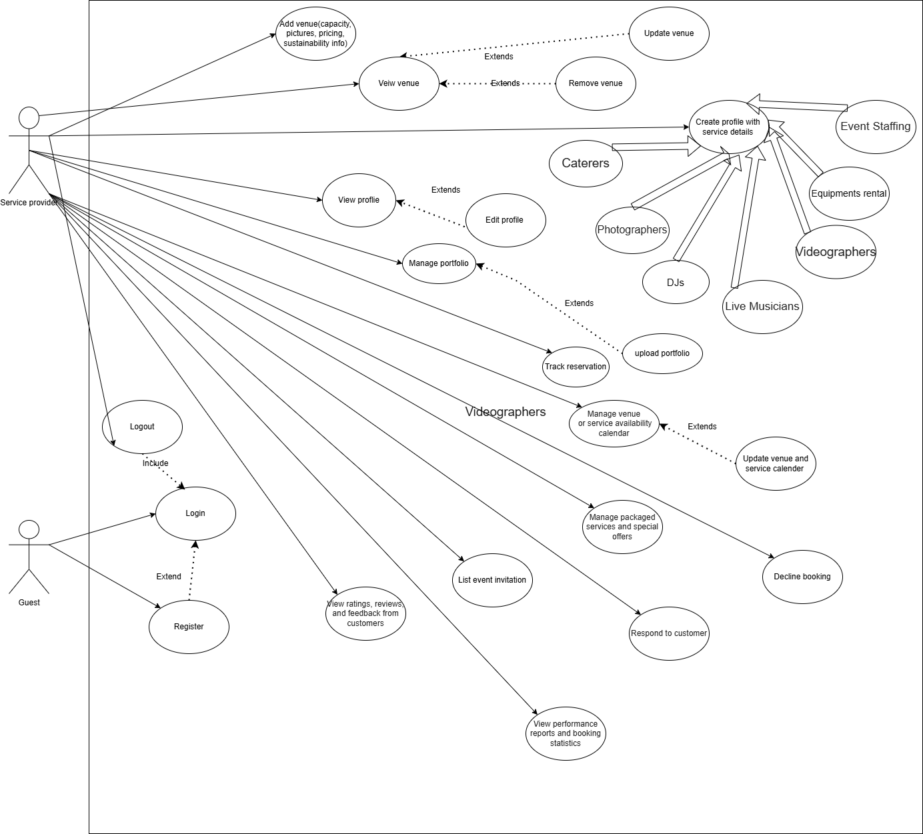

* + ***Customer Use-case diagram***

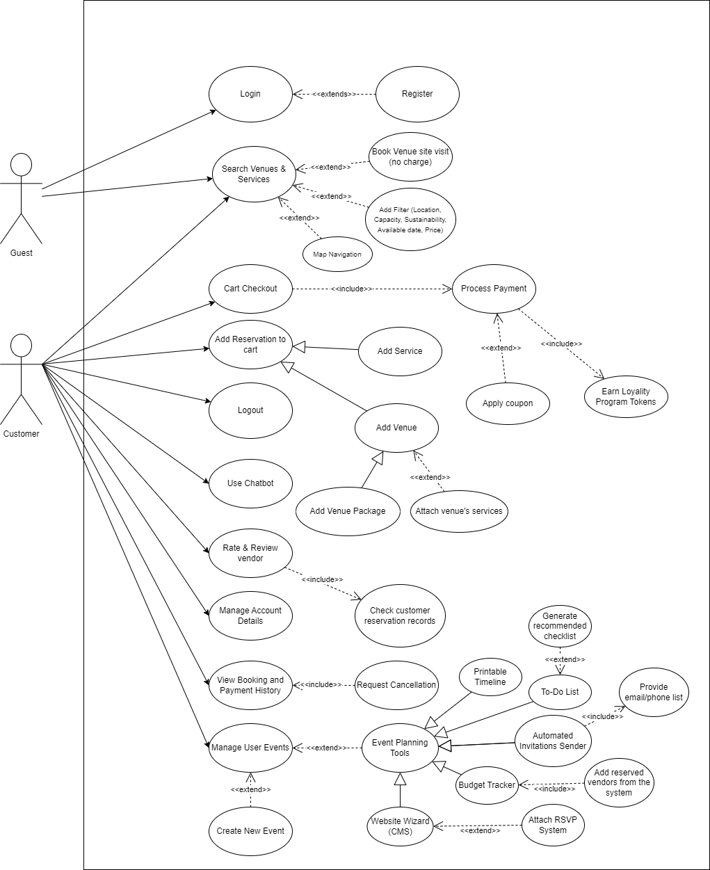

* + ***Admin Use-case diagram***

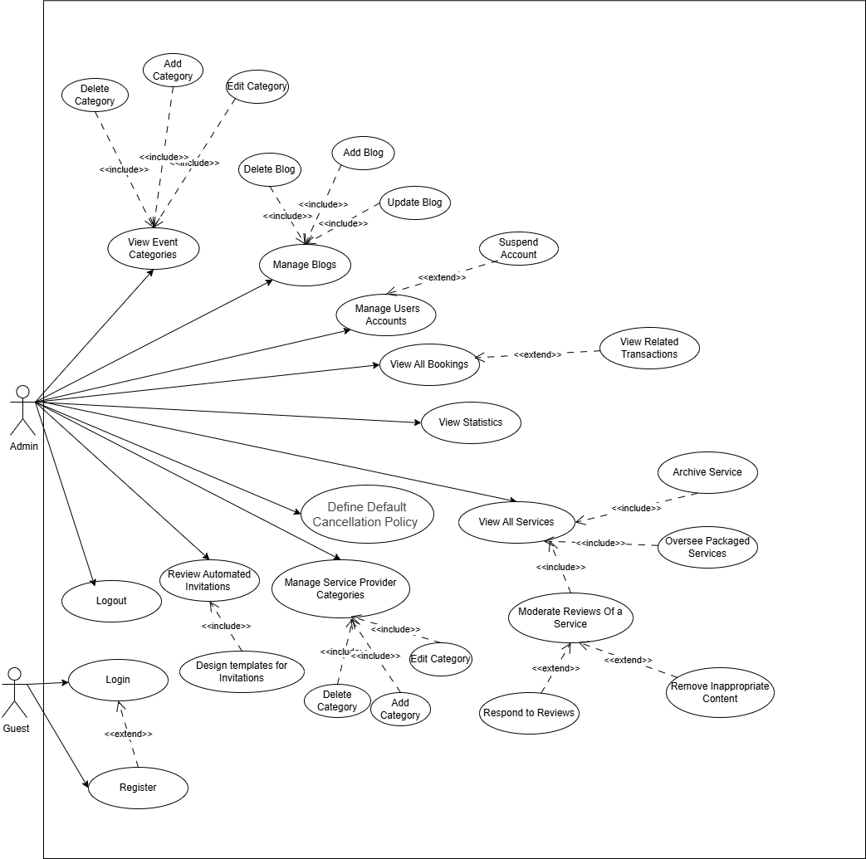

1. ***Class Diagram***
2. ***Sequence Diagram***
3. ***Entity Relationship Diagram (ERD) for your Database (if any)***
4. **Work Plan:**

In the following table, you should list everything you have done and are planning to do in order to finish your graduation project (overall plan of the project (Gantt chart). This includes the survey you have conducted to determine your project idea, the technologies you have learned or you are planning to learn to help you implement your project. It also includes the analysis and design of your system, its database analysis, and the already implemented parts, the testing effort, and the documentation.

|  |  |  |  |
| --- | --- | --- | --- |
| Task | Task Title | Description | Task status  (completed/expected in time ) |
| 1 |  |  |  |
| 2 |  |  |  |
| 3 |  |  |  |
| 4 |  |  |  |
| 5 |  |  |  |
| 6 |  |  |  |
| 7 |  |  |  |
| 8 |  |  |  |
| 9 |  |  |  |
| 10 |  |  |  |
| … |  |  |  |